TICKETS NOW ON SALE!

Friday, 8 September 2017

Tickets are now on sale at the Office for our school production “For Such a Time as This”. Tickets are $14 for adults and $5 for school-age children. (Obviously our children are free!) Spread the word to family and friends as this event is shaping up to be a truly memorable experience. To secure your tickets, give the Office a call to have your tickets reserved for you until you can come in and pay. (Or send the money in an envelope with you name and number of tickets required) We were going to make the ticket available online but the extra cost involved made it uneconomical to do so.)

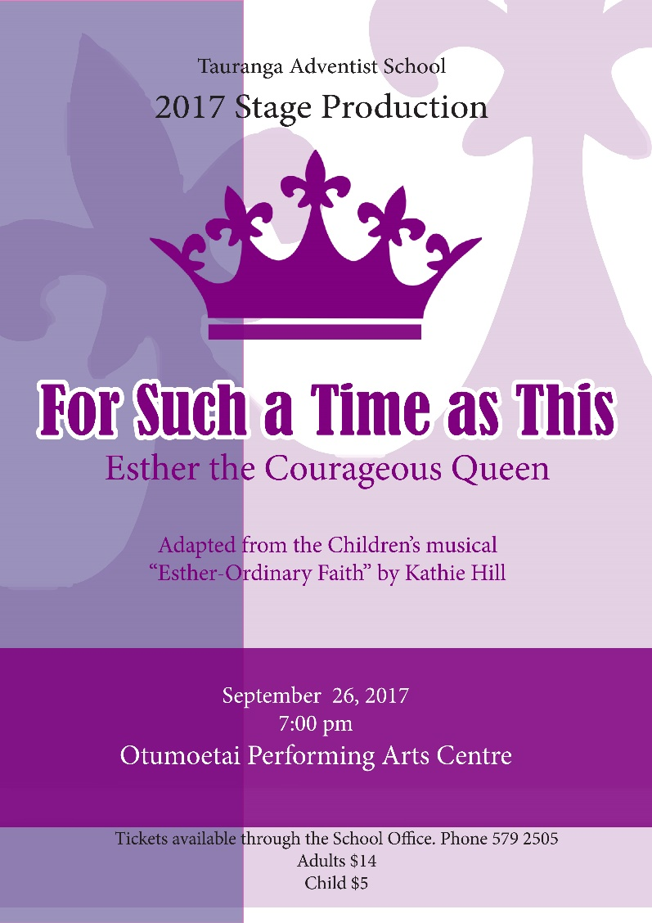

PARENT HELP WANTED MONDAY
If you have a spare hour or two next Monday and would be able to roll some paint on our stage set, please phone the Office as we would appreciate your help.
(or send an email tgasda.principal@xtra.co.nz)

